***“PROJECT TITLE”***

A MINI- PROJECT REPORT ON

Submitted in partial fulfillment of the requirements

For the degree of

Bachelor of Engineering

In

Information Technology

by

**Chinmay Shirsath 18IT1023**

**Prabhatkumar Singh 18IT2038**

**Siddharth Sahasrabuddhe 18IT1074**

Supervisor

**Nilima Dongre**



Department of Information Technology

Dr. D. Y. Patil Group’s

**Ramrao Adik Institute of Technology**

Dr. D. Y. Patil Vidyanagar, Sector 7, Nerul, Navi Mumbai 400706.

(Affiliated to University of Mumbai)

( 2020)

# rait logo

Ramrao Adik Institute of Technology

(Affiliated to the University of Mumbai)

Dr. D. Y. Patil Vidyanagar,Sector 7, Nerul, Navi Mumbai 400706.

CERTIFICATE

This is to certify that, Mini Project entitled

“ Stopwatch ”

is a bonafide work done by

Student Names

and is submitted in the partial fulfilment of the requirement for the

degree of

Bachelor of Engineering

in

Information Technology

to the

University of Mumbai

Supervisor

Prof. Nilima M. Dongre

Project Guide Head of the department

Nilima Dongre Dr. Ashish Jadhav

Certificate of Approval by Examiners

This Mini Project report entitled “ Project Title ” is a bonafide work done by Student Names under the supervision of Prof. Nilima Dongre approved for the award of Bachelor Degree in Information Technology, University of Mumbai.

Examiners :

1. . . . . . . . . . . . . . . . . . . . . . . . . . . . . . .

2. . . . . . . . . . . . . . . . . . . . . . . . . . . . . . .

Supervisors :

1. . . . . . . . . . . . . . . . . . . . . . . . . . . . . . .

2. . . . . . . . . . . . . . . . . . . . . . . . . . . . . . .

Principal :

. . . . . . . . . . . . . . . . . . . . . . . . . . . . . .

Date :

Place :

# **DECLARATION**

We declare that this written submission represents our ideas in our own words and where others' ideas or words have been included, we have adequately cited and referenced the original sources. We also declare that we have adhered to all principles of academic honesty and integrity and have not misrepresented or fabricated or falsified any idea/data/fact/source in our submission. We understand that any violation of the above will be cause for disciplinary action by the Institute and can also evoke penal action from the sources which have thus not been properly cited or from whom proper permission has not been taken when needed.

**Name and Roll No. of Students Signature**

1.Chinmay S. Shirsath 18IT1023

2.Prabhatkumar Singh 18IT2038

3.Siddharth Sahasrabuddhe 18IT1074

Date:

Place:

# ACKNOWLEDGEMENT

The project “Stopwatch” is creative work of many minds. A proper synchronization between individual is must for any project to be completed successfully. One cannot imagine the power of the force that guides us all and neither can we succeed without acknowledging it.

We take this opportunity to express my profound gratitude and deep regards to our Guide **Nilima Dongre**, Department of the Information Technology Engineering for her or her exemplary guidance, monitoring and constant encouragement throughout the completion of this mini project.

We would like to express our gratitude to **Dr. Ashish Jadhav,** Head of the department, Information Technology Engineering for encouraging and inspiring us to carry out the project in the department lab. We take this privilege to express my sincere thanksare thankful to **Dr. Mukesh D. Patil, Principal RAIT,** for his constant support and motivation.

We also would like to thank all the staff members Department of the Information Technology Engineering for providing us with the required facilities and support towards the completion of the project.

Last but not the least we are thankful to our parents and friends for their constant Inspiration, encouragement and well wishes by which we have made a challenging project.

1.Chinmay S. Shirsath 18IT1023

2.Prabhatkumar Singh 18IT2038

3.Siddharth Sahasrabuddhe 18IT1074

# **PREFACE**

We take great opportunity to present this Mini Project report on “**Stopwatch”** and put before readers some useful information regarding our project.

We have made sincere attempts and taken every care to present this matter in precise and compact form, the language being as simple as possible. We are sure that the information contained in this volume certainly prove useful for better insight in the scope and dimension of this project in it true perspective.

The task of the completion of the project though being difficult was made quite simple, interesting and successful due to deep involvement and complete dedication of our group members.

**TABLE OF CONTENTS**

**Declaration …………….…….………………………………………… I**

**Acknowledgement ……...……………………………………………… II**

**Preface …………….…………………………………………………… III**

**Table of Contents ……………………………………………………… IV**

**Table of figures ...…………………………………………………….… V**

**Abstract…….....…………………………………………………..…….. VI**

**TABLE OF CONTENTS**

**Sr. No. Topic Page No.**

1. **INTRODUCTION………………………………………………………………..10**
   1. **INTRODUCTION TO SCRIPTING LANGUAGES………………………11**
   2. **WHY PARTICULAR SCRIPTING LANGUAGE………………………...12**
2. **LITERATURE SURVEY……………………………………………………….14**
   1. **MOTIVATION………………………………………………………………141**
3. **PROPOSED SYSTEM…………………………………………………………..15**
   1. **HARDWARE AND SOFTWARE REQUIREMENTS……………………15**
4. **IMPLEMENTATION……………………………………………………………17**
   1. **SYSTEM BLOCK DIAGRAM……………….……………………………...17**
   2. **CODE………………………………………………………………………….18**
5. **RESULT…………………………………………………………………………...19**
   * 1. **OUTPUT SNAPSHOTS**
6. **CONCLUSION AND FUTURE SCOPE………………………………………..23**
   1. **CONCLUSION……………………………………………………………….23**
   2. **FUTURE SCOPE…………………………………………………………….23**
7. **REFERENCES……………………………………………………………………47**

**ABSTRACT**

**Stopwatches find use as time keeping devices in many fields, namely sports. Stopwatches may be analog or digital. Digital stopwatches are much more common the analog version owing to their higher accuracy and ease of use. Here we have tried to realize a digital stopwatch of reasonable accuracy and reliability. Here we design a type wherein the watch displays count from 0 to 59 in seconds, representing a 60 second time interval. The watch displays time in seconds, minutes and hours.**

**1 Introduction**

A stopwatch is designed to measure the amount of time that elapses between its activation and deactivation. A large digital version of a stopwatch designed for viewing at a distance, as in a sports stadium, is called a stopclock. In manual timing, the clock is started and stopped by a person pressing a button. In fully automatic time, both starting and stopping are triggered automatically, by sensors. The timing functions are traditionally controlled by two buttons on the case. Pressing the top button starts the timer running, and pressing the button a second time stops it, leaving the elapsed time displayed. A press of the second button then resets the stopwatch to zero. The second button is also used to record split times or lap times. When the split time button is pressed while the watch is running, the display freezes then starts then freezes again, allowing the elapsed time to that point to be read, but the watch mechanism continues running to record total elapsed time. Pressing the split button, a second time allows the watch to resume display of total time.

**1.1 Introduction to Bash**

Bash is a Unix shell and command language written by Brian Fox for the GNU Project as a free software replacement for the Bourne shell. First released in 1989, it has been used widely as the default login shell for most Linux distributions and Apple's macOS Mojave and earlier versions. A version is also available for Windows 10. It is also the default user shell in Solaris 11.

Bash is a command processor that typically runs in a text window where the user types commands that cause actions. Bash can also read and execute commands from a file, called a shell script. Like all Unix shells, it supports filename globing (wildcard matching), piping, here documents, command substitution, variables, and control structures for condition-testing and iteration. The keywords, syntax, dynamically scoped variables and other basic features of the language are all copied from sh. Other features, e.g., history, are copied from csh and ksh. Bash is a POSIX-compliant shell, but with a number of extensions.

The shell's name is an acronym for Bourne-again shell, a pun on the name of the Bourne shell that it replaces and the notion of being "born again".

**1.2 Why particular scripting language**

It’s the most efficient shell scripting language. It gives you the easiest way to automate things if you are already familiar with using a shell interactively. If you’re programming systems then you should know how the shell works anyway.

If you compare bash scripting to learning a yaml or json based configuration or automation framework it is a lot more versatile. These frameworks that expect you to declare everything in a yaml or json file often make something that would ordinarily be simple in an a bash script because the bash script operates sequentially by default. Try something simple like do 3 things in order with these declarative languages and you end up linking a chain of dependencies. If you want to be constrained into a framework of declaring dependencies then maybe bash isn’t for you. It’s not that sophisticated. You write statements at the top and those get executed before the ones closer to the bottom. You still can write functions if you want. This is much more intuitive for people who aren’t already familiar with programming in a declarative language (and also more intuitive than working in a language that isn’t sure if it’s imperative or declarative and has both implementations etc.)

If you take it upon yourself to invest the time required to learn a domain specific language, and learn it well, and keep up with it, then you have knowledge of what the makers of that language say is the current best way to solve problems in that domain. The may change their approach. Bash isn’t that sophisticated nor that specific. I like to think of bash as the domain specific language for programming and automating the shell.

In terms of systems automation, if you think something is better than bash, maybe you think something is better than the shell or maybe you don’t want to learn so much about the shell and want to learn something more specific.

Sometimes simpler is better. Bash is a simpler language and it forces you to focus on bigger systems problems. Not everything that’s challenging is a programming problem. Bash works nicely for scripting the shell. Everything else basically either uses the shell for commands or implements its own shell (basically copying what I hope is the good parts from bash).

**2. Literature Survey**

**2.1 Motivation**

Stop watch is a professional timing/counting equipment. Normal watch’s main function is time display.

Like this professional sports stopwatch and counter, it can record the following parameters: Total time, Total laps, Average time for each lap, Fastest lap time, slowest lap time, Individual lap time for every lap… More important function is its vibrate alarm function according to your preset lap or time.

Obviously, your normal watch, even if your water proof watch, doesn’t have above professional functions.

**3. Proposed System**

**Hardware and Software requirements**

In computing, a shell is a user interface for access to an operating system's services. In general, operating system shells use either a command-line interface (CLI) or graphical user interface (GUI), depending on a computer's role and particular operation. It is named a shell because it is the outermost layer around the operating system.

Command-line shells require the user to be familiar with commands and their calling syntax, and to understand concepts about the shell-specific scripting language (for example bash).

In addition to shells running on local systems, there are different ways to make remote systems available to local users; such approaches are usually referred to as remote access or remote administration. Initially available on multi-user mainframes, which provided text-based UIs for each active user simultaneously by means of a text terminal connected to the mainframe via serial line or modem, remote access has extended to Unix-like systems and Microsoft Windows. On Unix-like systems, Secure Shell protocol is usually used for text-based shells, while SSH tunneling can be used for X Window System–based graphical user interfaces (GUIs). On Microsoft Windows, Remote Desktop Protocol can be used to provide GUI remote access, and since Windows Vista, PowerShell Remote can be used for text-based remote access via WMI, RPC, and WS-Management.

**4. Implementation**

**4.1 Block Diagram**

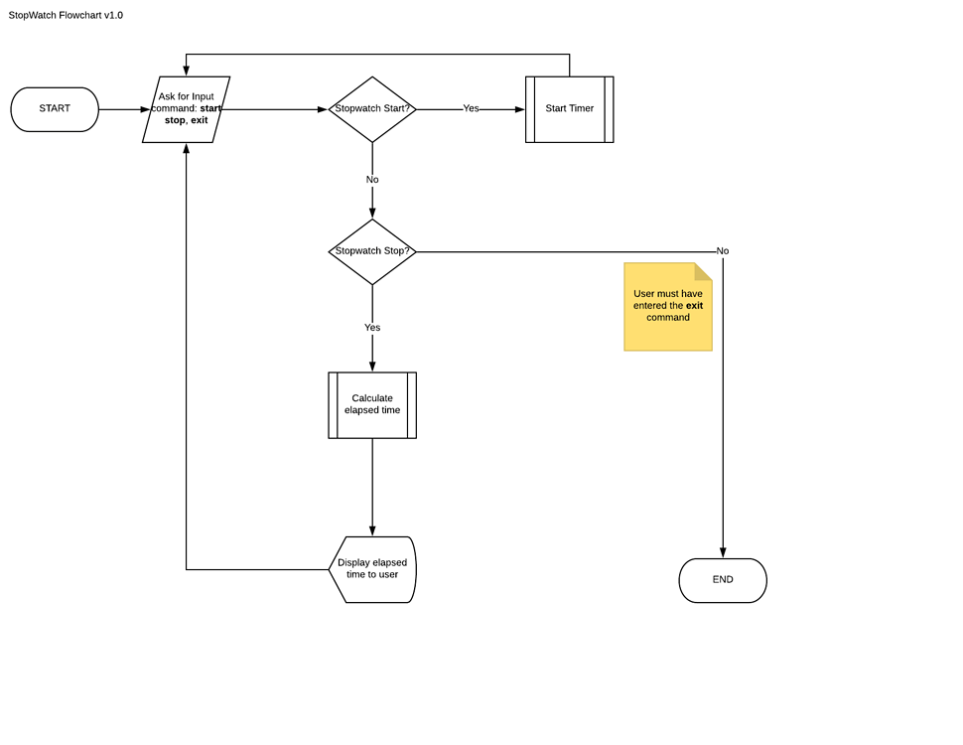

**4.2 Code**

tmp="$HOME/.mytimer.tmp"

if [ "$1" = "new" ] && [ -f "$tmp" ]

then

rm "$tmp"

fi

function main(){

echo "Welcome to my timer"

check_timer;

start_timer

exit 0

}

function check_timer(){

if [ -f "$tmp" ]

then

echo "Timer Reloaded - To restart run '$0 new'"

let start_time="$(cat $tmp)";

else

echo "New Timer Started"

let start_time="$(date +%s)";

echo "$start_time" > "$tmp"

fi

}

function start_timer(){

while [ 1 ];

do

let current_time="$(date +%s)"

let seconds=$current_time-$start_time;

echo -en "\r \r"

printf "Timer: %02d:%02d:%02d:%02d" "$((seconds/86400))" "$((seconds/3600%24))" "$((seconds/60%60))" "$((seconds%60))"

sleep 1;

done

}

main

**5. Result**

**The stopwatch starts:**

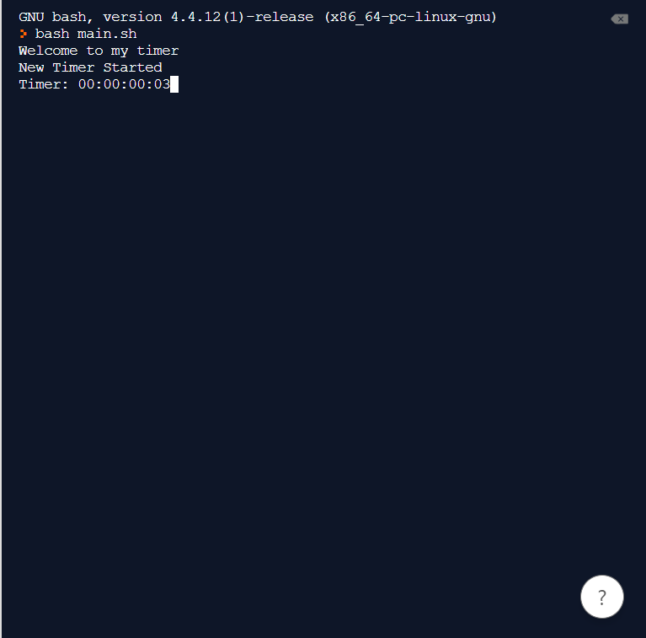

**When a lap is completed:**

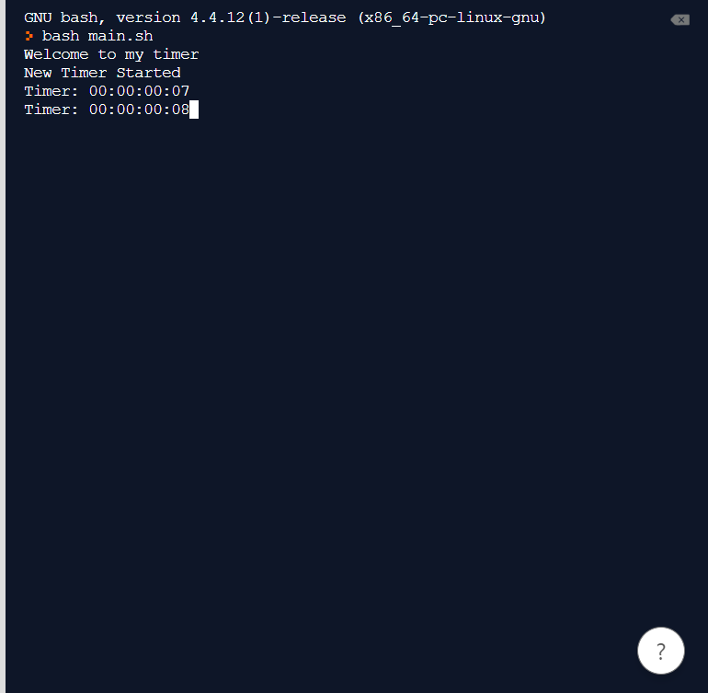

**When program is terminated:**

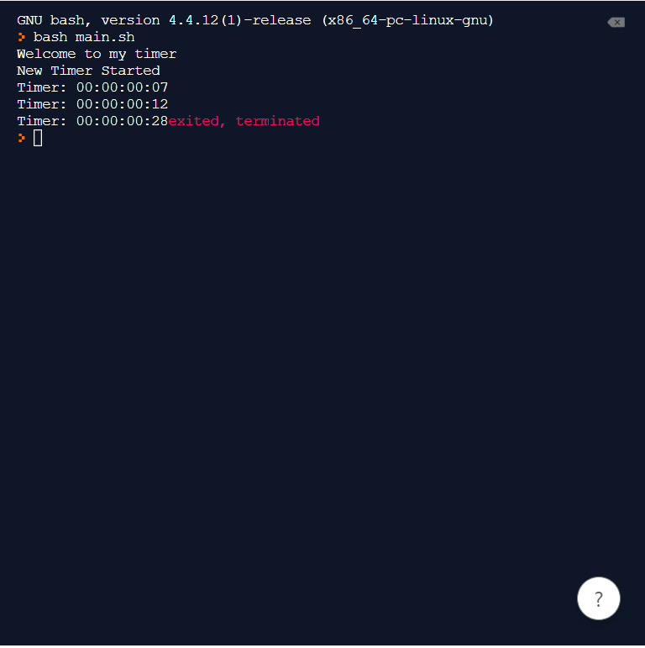

**6.1 Conclusion**

In the end, we conclude that we made a Stopwatch using bash script. It can be very useful to measure small time period and count laps.

**6.2 Future Scope**

Everybody needs a stopwatch at some point. The stop watch function is also present as an additional feature in many digital wrist watches, cell phones and portable music players.

Online stopwatches are also available by which you can use the stop watch in full screen. It isreally great for meetings, classrooms, conferences, schools and anywhere.

Stopwatches, countdown timers, make your daily life pretty simple and smooth.

**7. References**

* Wikipedia
* Google
* Geekforgeeks
* YouTube